DOCKER-COMPOSE

Task - Setup and Manage Docker Compose for Multicontainer.

Trainer:-

Siddharth Sharma.

Trainee:-

Yash Ketkale**.**

Step 1: Check the docker compose version

$ docker-compose --version

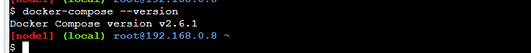

Step 2: Create an empty project directory

$ mkdir dockercomposefile



Step 3: Change into your project directory.

$ cd docekercomposefile/

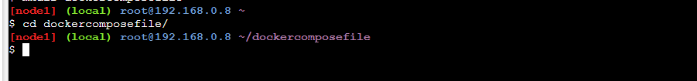

Step 4: Create a file inside the directory

$ touch docker-compose.yml



Steps 5: We are going to create simple docker compose file as an example. Here is the contents of my compose file.

$ vi docker-compose.yml

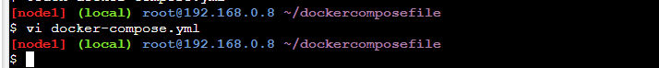

Steps 6: Type below steps for docker compose

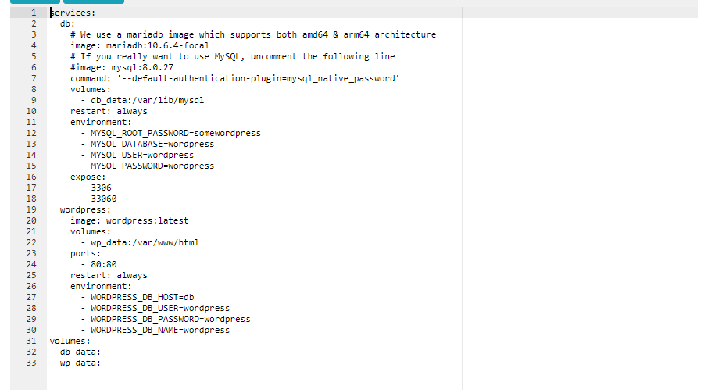

Steps 7: Type below command to check everything in docker compose is correct.

$ docker-compose config

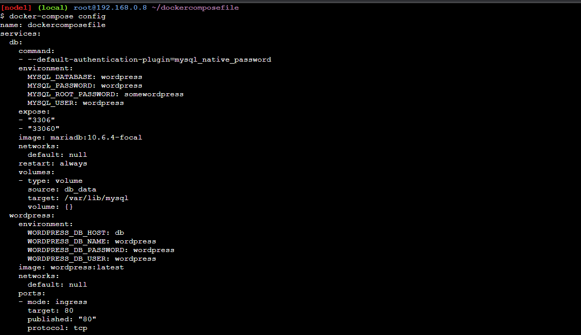

Steps 8: Now let’s run the docker compose ( -d is for background)

$ docker-compose up –d

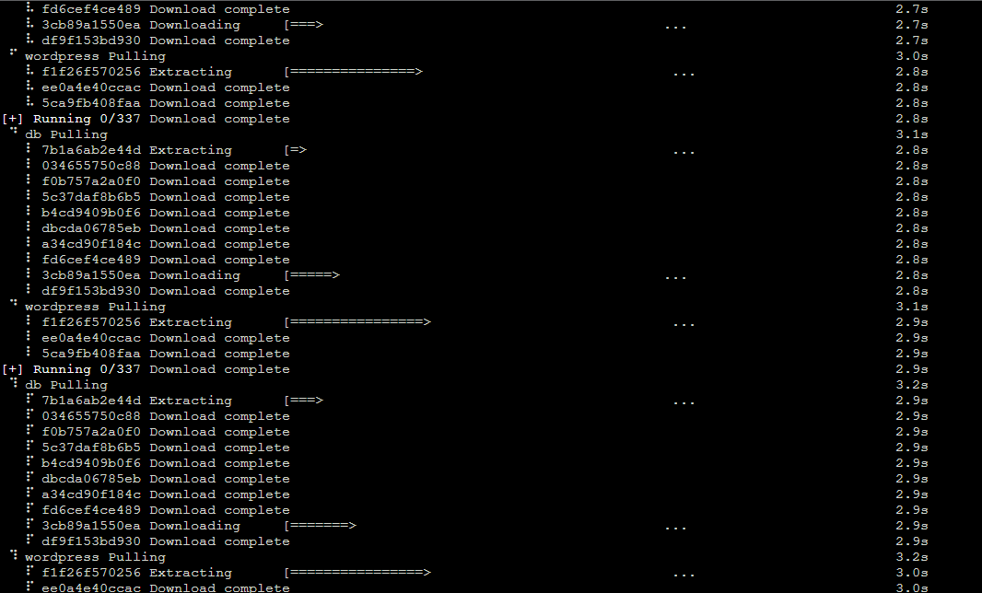

Steps 9: Now let’s check the Docker ps

$ docker ps

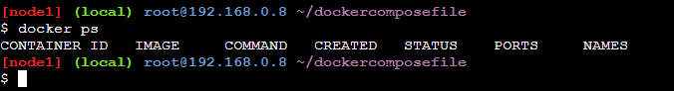

Steps 10: Bring down the application by command

$ docker-compose down

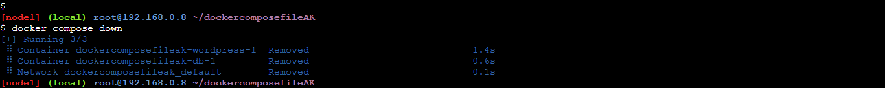

Step 11: scale the service like wordpress

$ docker-compose up -d –scale wordpress=4

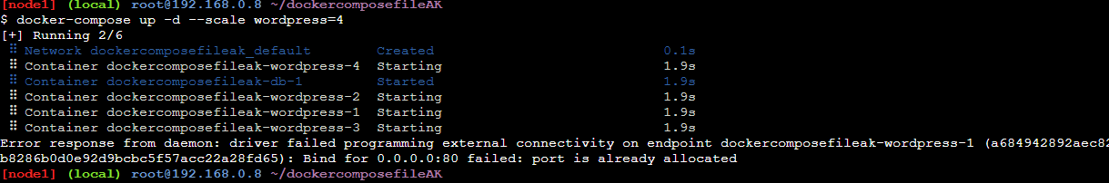

Steps 12 : Check the no of running container

$ docker ps



Steps 13: down the container

$ Docker-compose down

